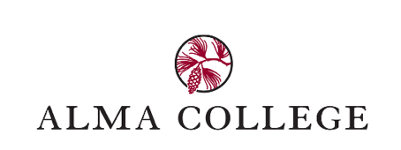
Para to Pro: District Administration Agree to Support
Dear Administrator,
A paraeducator from your district is seeking to enroll in Alma College’s Para to Pro Program to become a fully certified special education teacher with endorsements in Learning Disabilities (LD), Cognitive Impairment (CI), and Emotional Impairment (EI). To move forward, the district’s partnership and support are essential and required for the paraeducator to be enrolled in the program. While the paraeducator will receive credit for work experience, there are required clinical components. The table below outlines the district’s commitment and Alma College’s responsibilities.
Area | District Role & Support Needed | Alma College Role
Mentor Teacher | Assign a special education–endorsed mentor teacher who is available to provide guidance, verify clinical hours, and complete a total of 6 evaluations prior to student teaching (10-15 minutes each via TK20) throughout the program. Mentor teachers are eligible for SCECH hours. | Provide mentor guidance, evaluation links, and support.
Clinical Experience | Allow the paraeducator to complete clinical experience hours while employed in the district:  - 270 hours with students with disabilities (PK–12, complete on the job)  If the paraeducator is not working in the following settings, some job flexibility in years 2-4 of the program will be needed to complete:  - 20 hours with students ages 14-26, 30 hours in elementary math, 30 hours in elementary literacy | Monitor, verify, and provide feedback on all clinical experiences.
Student Teaching | Assist with securing a 14-week special education student teaching assignment in the final semester. The district may choose to continue employment during this time. | Conduct two virtual meetings with the paraeducator and mentor teacher
If you agree that the paraeducator is a good fit for this program, and your district can provide this support, please complete the following:
Based on the past performance of the paraeducator, I agree to the above support plan. I believe the paraeducator is a good candidate for a special education teacher preparation program. I understand that this agreement will remain valid for the duration of the paraeducator’s employment in the school district.

Name of Paraeducator: ______________________________________________________

School Administrator Name: __________________________________________________

School Administrator Signature: _______________________________________________

Name of School District: _____________________________________________________

Employment Status: ___________ Date______________________________________

Please email this form to admissions@alma.edu. Thank you for your partnership and commitment to this important work.
Dr. Peggy Yates
Alma College – Director, Para to Pro Program, yatespa@alma.edu

